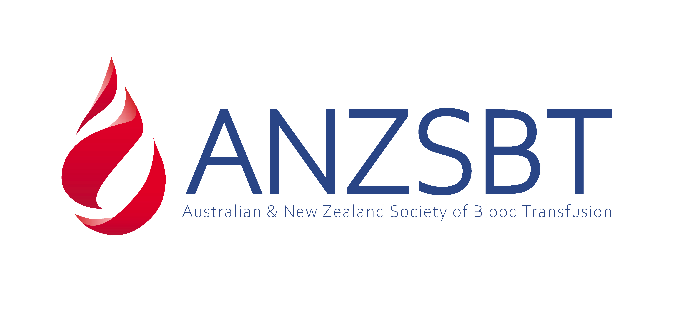

ANZSBT Member Mentorship Program Application Form 2025
Welcome to the ANZSBT Member Mentorship Program Application Form. Please complete the following sections to apply for the 2025 program. This form is designed to capture your demographic information and help us match you with a suitable mentor or mentee.
Please note that you must be a current member of ANZSBT to participate in this program

Personal Information
- Full Name
Please enter your first and last name.
- Country of Residence
Country
- Contact Information
  - Email Address
Provide a valid email address for correspondence.
  - Phone Number
Include country and area code.
- Spoken Languages
Please include all spoken languages
- Written Languages
Please include all written languages

Professional Background
- What is your profession?
Please specify including job title.
- Organization/Institution (including City & Country)
Name of the organization or institution you are currently affiliated with.
- Years of Experience in the Field
Indicate the total number of years.
- Areas of Expertise - Please also include your CV
List your areas of expertise, separated by commas.
- How long have you been in this profession?
<1 year
1-5 years
5-10 years
10-20 years
>20 Years
- Are you currently studying?
Yes/No
If yes, what is the name of the course as well as name, city and country of the institution
- What is the highest level of education that you are currently completing?
Certificate / diploma program (community college, technical college etc)
Undergraduate Degree (Bachelors degree)
Graduate Degree (Master's, Doctoral etc)
Other

Mentorship Program Information
- Are you applying as a:
  - Mentor
  - Mentee
  - Both Mentor and Mentee
- Please provide a short Biography (max 150 words)
Please provide details
- Please list your top 4 (four) professional areas of interest
1.
2.
3.
4.
- Please list your top 4 (four) career/professional goals
1.
2.
3.
4.
- Please share what you hope to gain from this mentorship program
Please provide details
- Have you previously participated in a mentorship program?
Yes/No
If yes, what was your experience with the mentorship program?

Availability
Providing this information allows us to better match mentors and mentees
- Please provide your usual availability (please provide all days that suit)
Monday
Tuesday
Wednesday
Thursday
Friday
- Please provide your preferred mode of communication with Mentor/Mentee (please select all that suit)
Email
Phone
Telephone
Please ensure all information is accurate before submitting your application. Thank you for your interest in the ANZSBT Member Mentorship Program 2025!

